
UML Company
ระบบจัดการธุรกจิการให้บริการห้องพัก(Room Soft)

Version 1.0

Prepare by
Miss Sasipa Wangkaew 573021308
Mr.Piyaboot Jaroenpong 5730213010
Miss Sirinya Hwanphet 5730213081

<27/10/2559>
สารบัญ

หน้า

1. Revision History....................................................................................................................1
2. Use Case Overview................................................................................................................1
Use Case Diagram Level 0: Inventory and Point of Sale Management System.........................1
Use Case Diagram Level 1: Personal Management Sub-System (UC100) ............................2
Use Case Diagram Level 1: Inventory Management Sub-System (UC200) ..........................2
Use Case Diagram Level 2: Customer Management (UC12) ................................................2
3. System Structure...................................................................................................................3
4. Static Structure and Data Analysis.......................................................................................4
4.1 Model-View-Controller (MVC) Model ............................................................................4
4.2 Entity Class Model.............................................................................................................5
5. System Behavior Model......................................................................................................6
Sequence Diagram demonstrating operation “add new customer” ...........................................6

- Revision History
Name | Date | Description | Version
Customer Management | 27/10/2559 | Use Case Diagram | RoomSoft System #1

- Use Case Overview
Use Case Diagram Level 0: Room Soft System

Use Case Diagram Level 1: Customer Management sub-system [UC100]

Use Case Diagram Level 1: Customer Management sub-system [UC200]
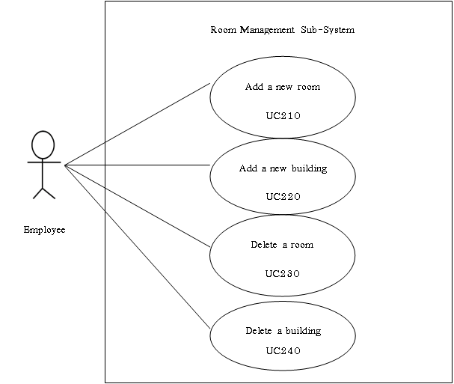

Use Case Diagram Level 1: Customer Management sub-system [UC300]

- System Structure

Room Soft System
Customer Manage
Room Manage
Reservation Manage
Add new room
Add new building
Delete room
Delete building
Add new reserve the room
Add new rental the rooms
Delete reserve the rooms
Print document rental agreement
Insert a new customer data
Update an existing customer data
Delete a customer data
Display a customer report

- Static Structure and Data Analysis
  - Model-View-Controller (MVC) Model
- Customer Management sub-system
- Insert customer data

- Update customer data

- Delete customer data

- Display customer data

- Room Management sub-system
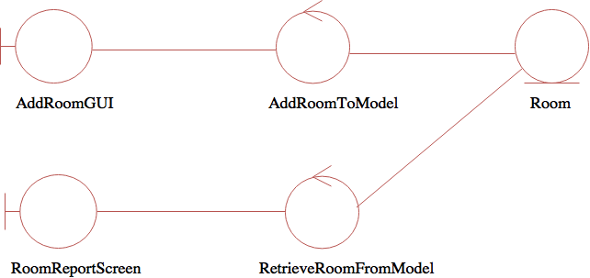
- Add a new room

- Add a new building
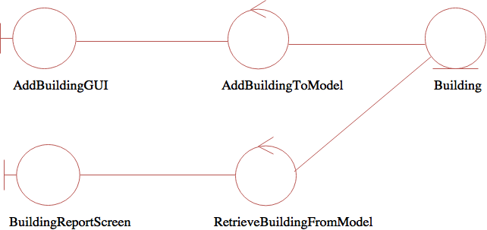

- Delete a room
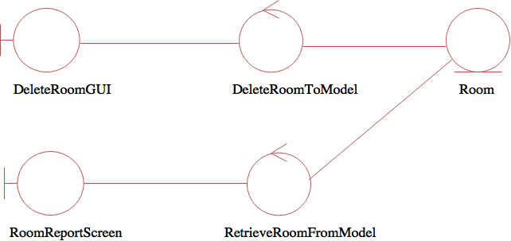

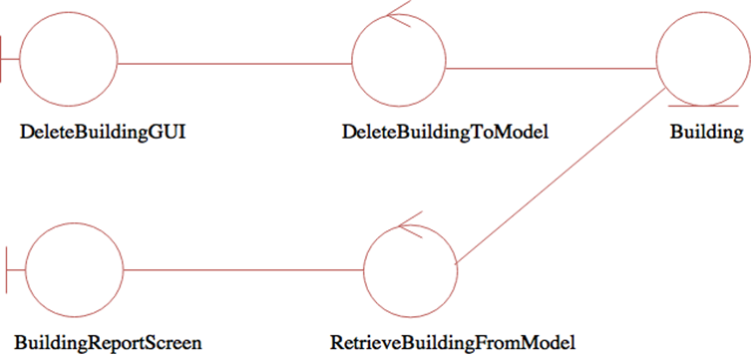
- Delete a building

4.2 Entity Class Model

5. System Behavior Model
Sequence Diagram demonstrating operation “Insert customer data”
• This diagram describes the system scenario of “UC110: Insert customer data”

Sequence Diagram demonstrating operation “Update customer data”
• This diagram describes the system scenario of “UC120: Update customer data”

Sequence Diagram demonstrating operation “Delete customer data”
• This diagram describes the system scenario of “UC130: Delete customer data”

Sequence Diagram demonstrating operation “Display customer data”
• This diagram describes the system scenario of “UC140: Display customer data”

Sequence Diagram demonstrating operation “Add a new room”
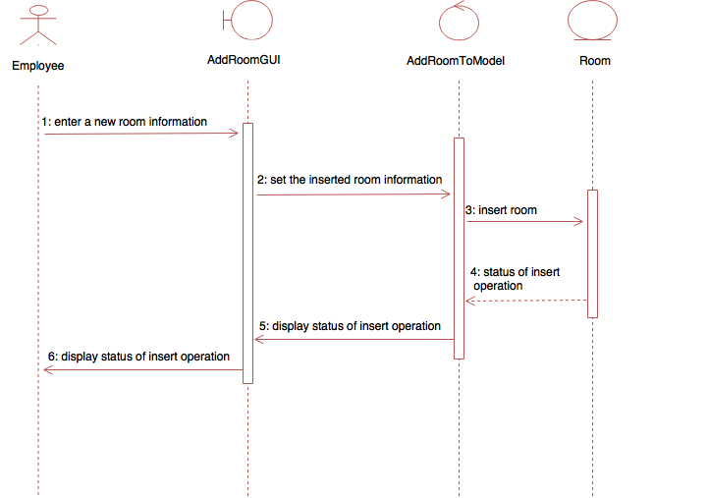
• This diagram describes the system scenario of “UC210: Add a new room”

Sequence Diagram demonstrating operation “Add a new building”
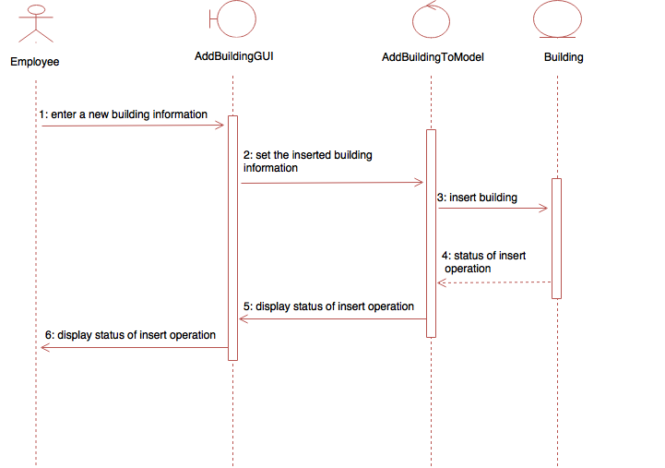
• This diagram describes the system scenario of “UC220: Add a new building”

Sequence Diagram demonstrating operation “Delete a room”
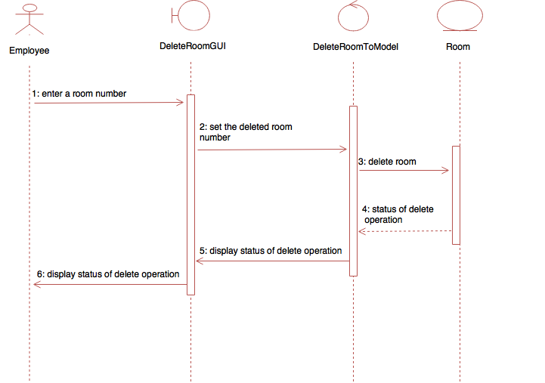
• This diagram describes the system scenario of “UC230: Delete a room”

Sequence Diagram demonstrating operation “Delete a building”
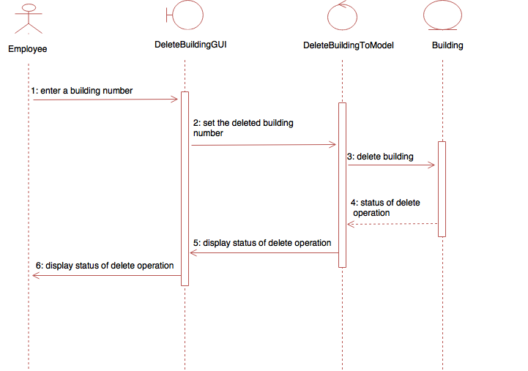
• This diagram describes the system scenario of “UC240: Delete a building”

